Andrew Jackson
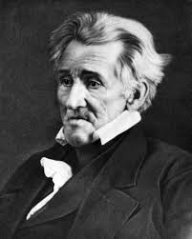

Who does the President of the United States Represent?

Populist Movement-

“I am the King of the people,” “Government is bad”
-Andrew Jackson

Background
Childhood-

Revolutionary War-

Personality-

Wife-

Duals

How to Dual

Jackson vs. Dickenson

Education
Courtroom-

Battlefield-

Becomes a National Hero at the Battle of New Orleans

Runs for President in Election of 1924 against John Quincey Adams

Creates the Democratic Party
-Represents the Common Person
-Strong Federal Government
-Symbol

Results of Election of 1924-

Election of 1928-

Inauguration Party-

Policies

Good Policies

 | Good | Bad
Nationalism
Sectionalism

Nullification-

1830- South Carolina-

-Vice-President- John C. Calhoun opinion

-President Jackson opinion

Bad Policies

1833- Shuts down Federal Banks

Indian Policy

Background
1800-1836 Indian Policy-

Cherokee-

1833-

Cherokee vs. United States of America court case-

Jackson Response-

Indian Removal Act-

Trail of Tears-

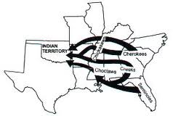

What do you think about the American Holocaust?

